Hydrogenation of phenol gives:
A. Salicylic acid
B. p-benzoquinone
C. Cyclohexanol
D. Sodium phenoxide
ANSWER: C
Complete the following equation:
A. 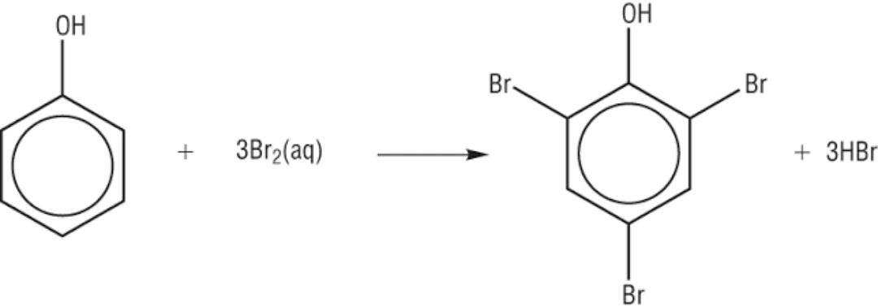
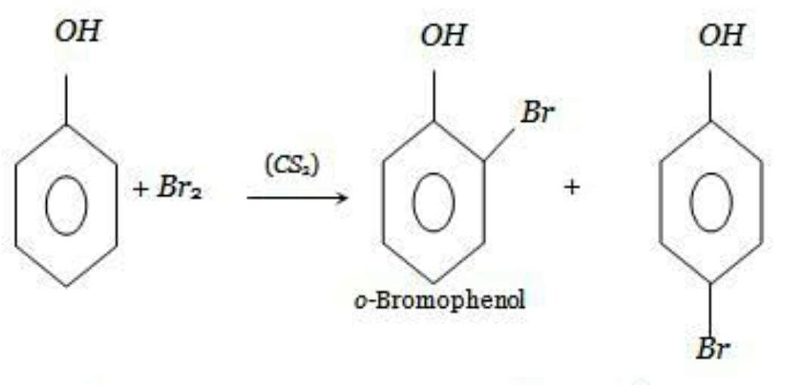
B.

C.

D. All of these
ANSWER: B
When phenol reats with nitric acid at high tempertaure ______________ product is obtained.
A. o-nitro phenol
B. 2,4,6-tri nitrophenol
C. p-nitro phenol
D. m-nitro phenol
ANSWER: B
What happens when phenol reacts with formladehyde?
A. Benzoic acid is produced
B. Cyclo hexanol is produced
C. Bakelite is produced
D. No reaction occurs
ANSWER: C
What product will be formed when phenol reacts with zinc dust?
A. Hydroquinone
B. Sodium phenoxide
C. Benzene
D. Zinc benzoate
ANSWER: C
Complete the following reaction:
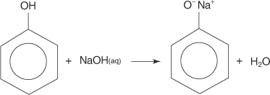
A.
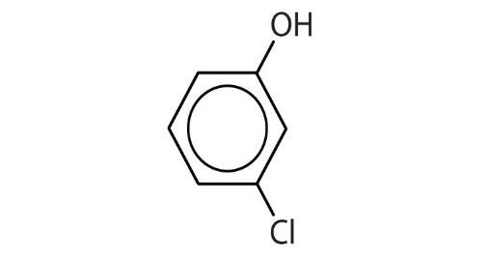
B.
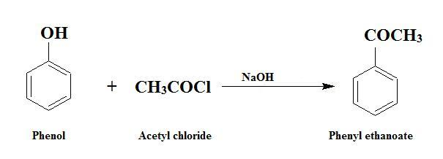
C.
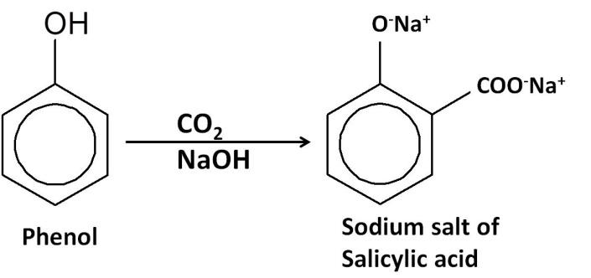
D.

ANSWER: D
When phenol reacts with acetyl chloride ___________ is formed.
A. Benzene
B. Phenyl acetate
C. Sodium phenoxide
D. p-hydroxybenzyl chloride
ANSWER: B
Which of the following reaction proves acidic nature of phenol?
A. Phenol reacts with acetyl chloride
B. Phenol reacts with caustic soda
C. Phenol reacts with Zinc
D. All of these
ANSWER: B
Chlorobenzene on heating with $10\%$ of $NaOH$ at ${300}^{0}C$produces:
A. Sodium benzoate
B. Sodium phenoxide
C. Phenol
D. Resorcinol
ANSWER: B
Preparation of phenol from the following process is commonly known as:

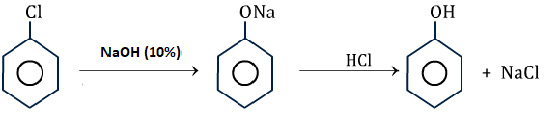
A. Down’s process
B. Nelson cell
C. Sepik’s process
D. Ostwald process
ANSWER: A
_________ product is formed, when benzene undergo halogenation reaction ($Cl_{2})$ in the presence of catalyst ($FeCl_{3})$:
A. Cyclo hexane
B. Phenol
C. Chloro benzene
D. Cyclo hexanol
ANSWER: C
Phenol reacts with ___________ to produce ortho-nitro phenol.
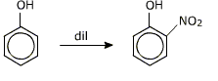
A. $NO_{2}$
B. $NaOH$
C. $HNO_{3}$
D. $HCl$
ANSWER: C

Treating phenol with formaldehyde in the presence of dilute base forms Bakelite. The process involved is:
A. Oxidation
B. Elimination
C. Condensation polymerization
D. Additional polymerization
ANSWER: C
When phenol passes over red hot dust, it reduced to ________ .
A. Carbolic acid
B. Catechol
C. Benzene
D. Sodium benzoate
ANSWER: C
Phenols react with bromine water to produce:
A. 4,5,6-tri bromo phenol
B. 3,5-di bromo phenol
C. 2,6-di bromo phenol
D. 2,4,6-tri bromo phenol
ANSWER: D

